EXP 1:PASSPORT AUTOMATION SYSTEM

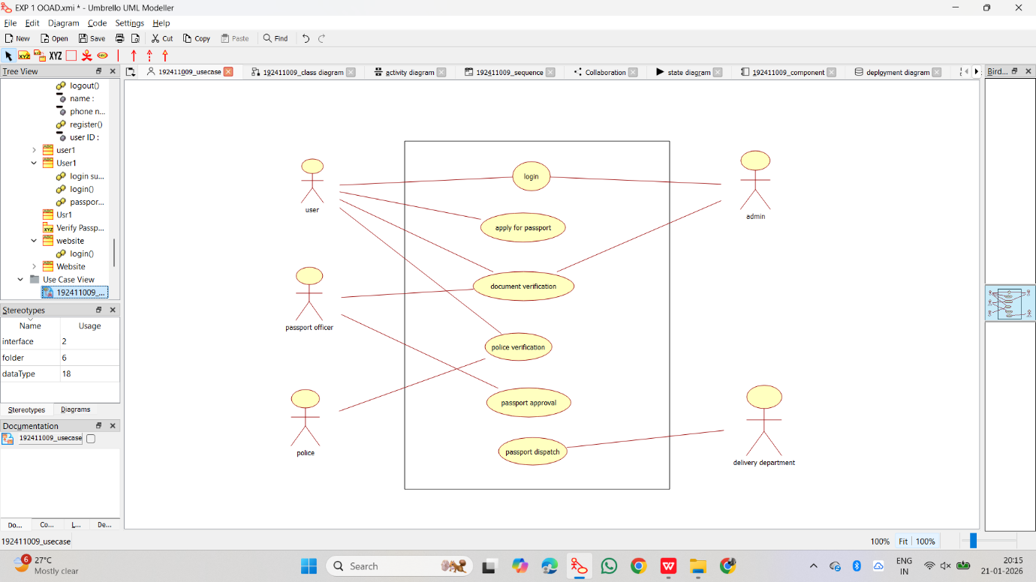
1.USE-CASE DIAGRAM:

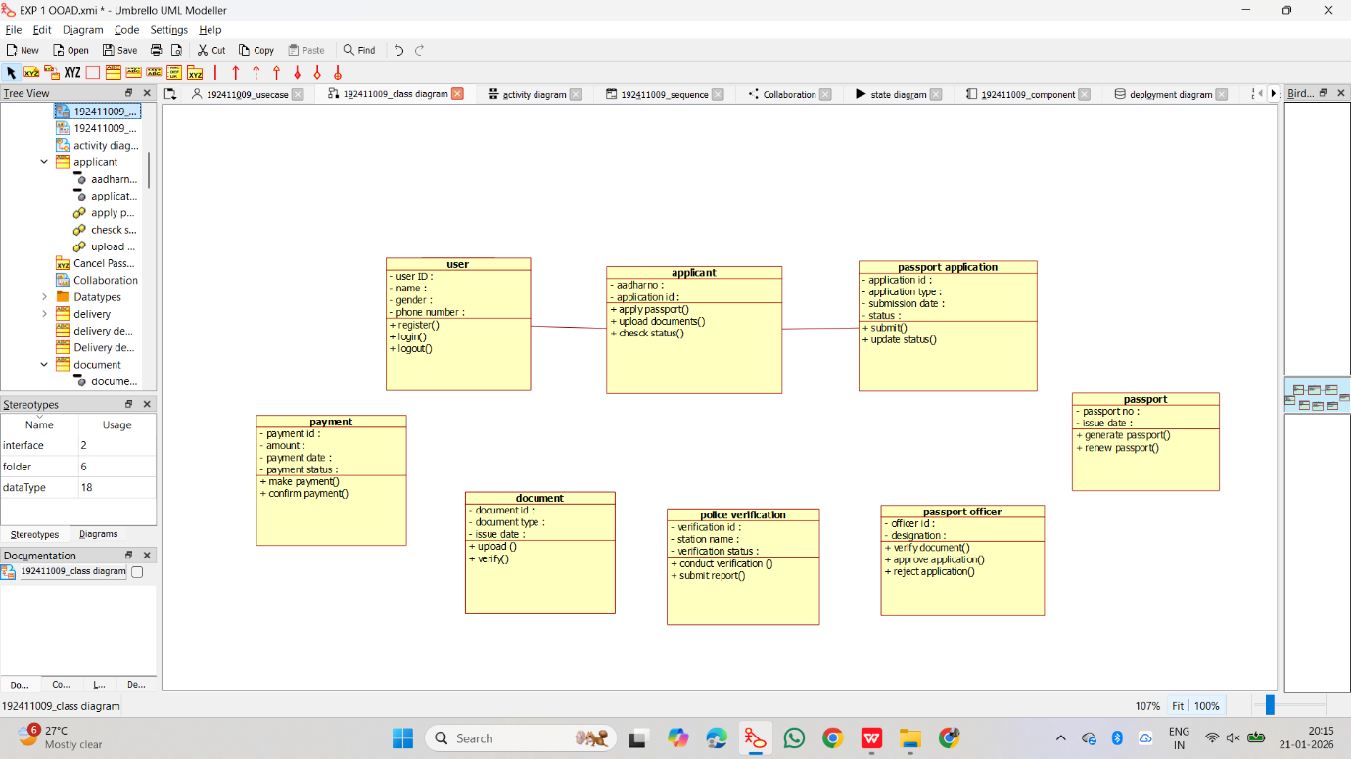
2.CLASS DIAGRAM:
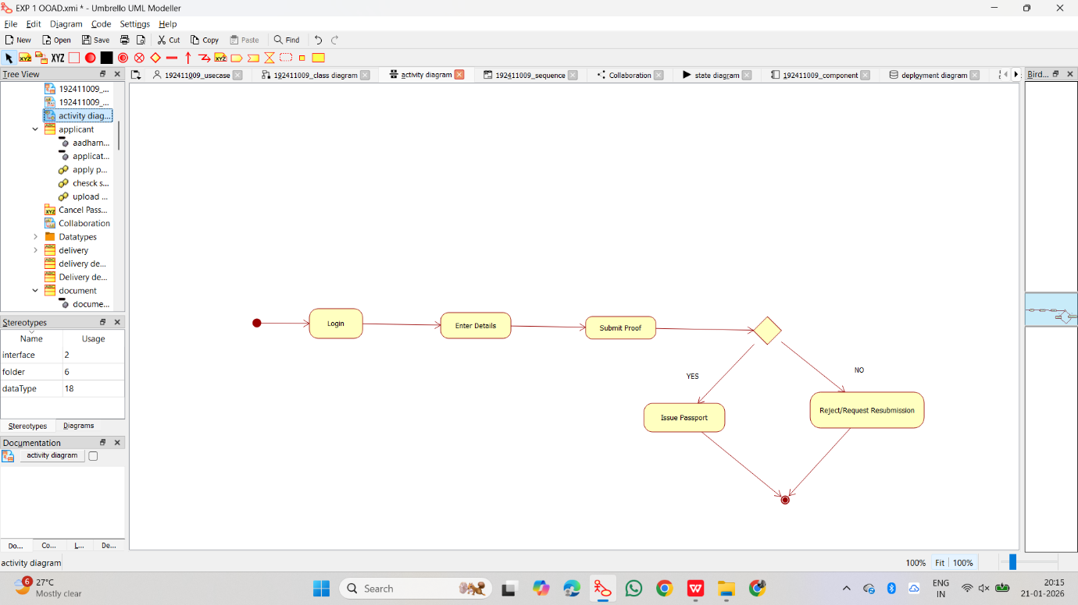
3.ACTIVITY DIAGRAM:

4.SEQUENCE DIAGRAM:
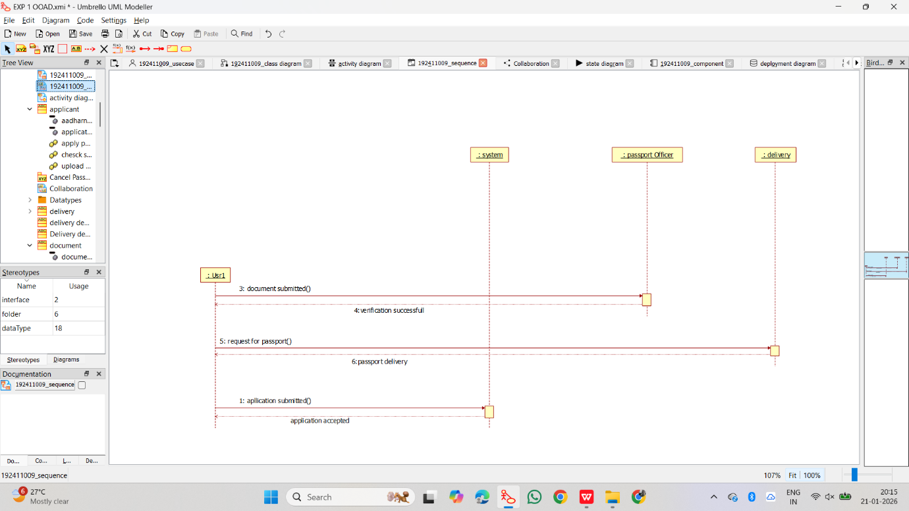

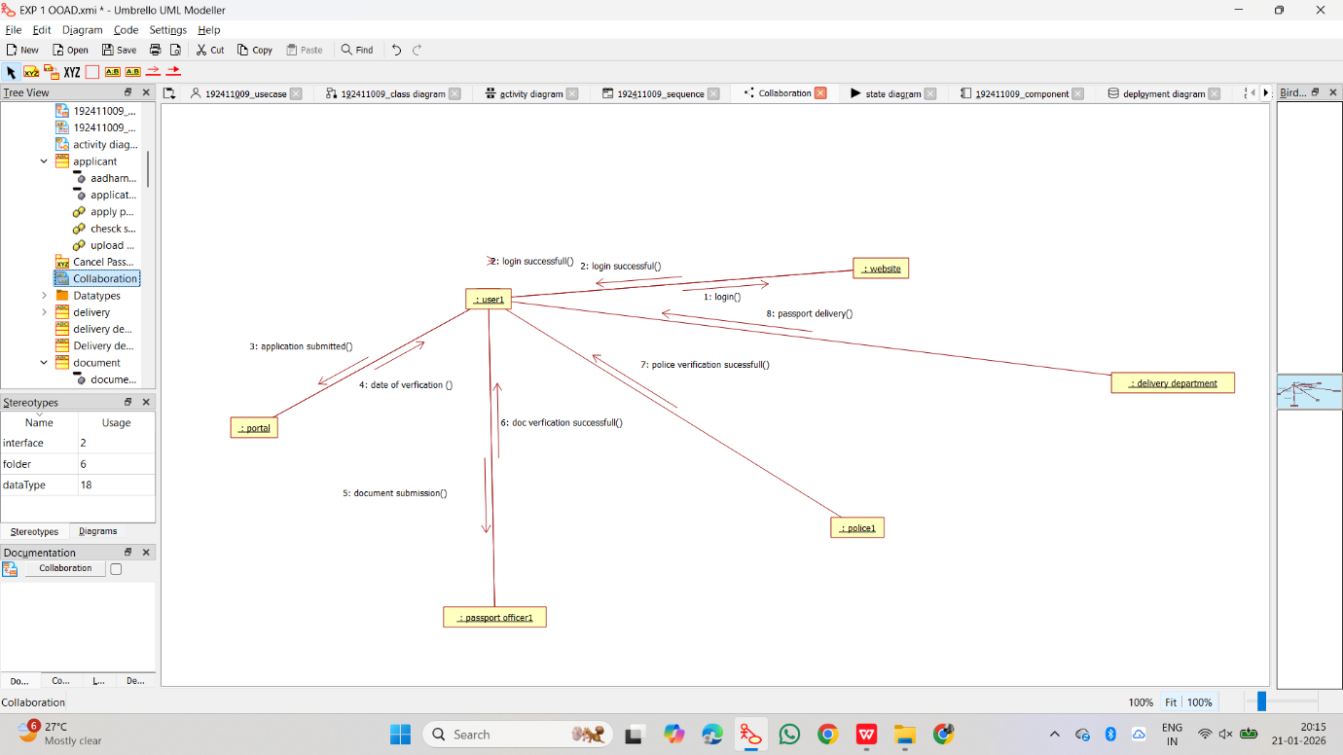
5.COLLABORATION DIAGRAM:

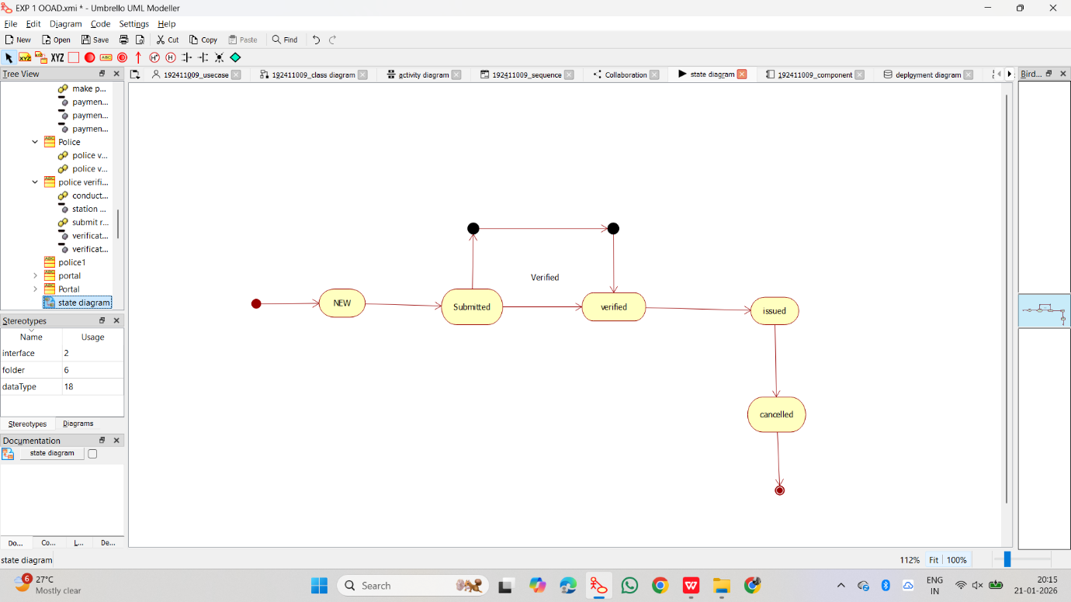
6.STATE-CHART DIAGRAM:

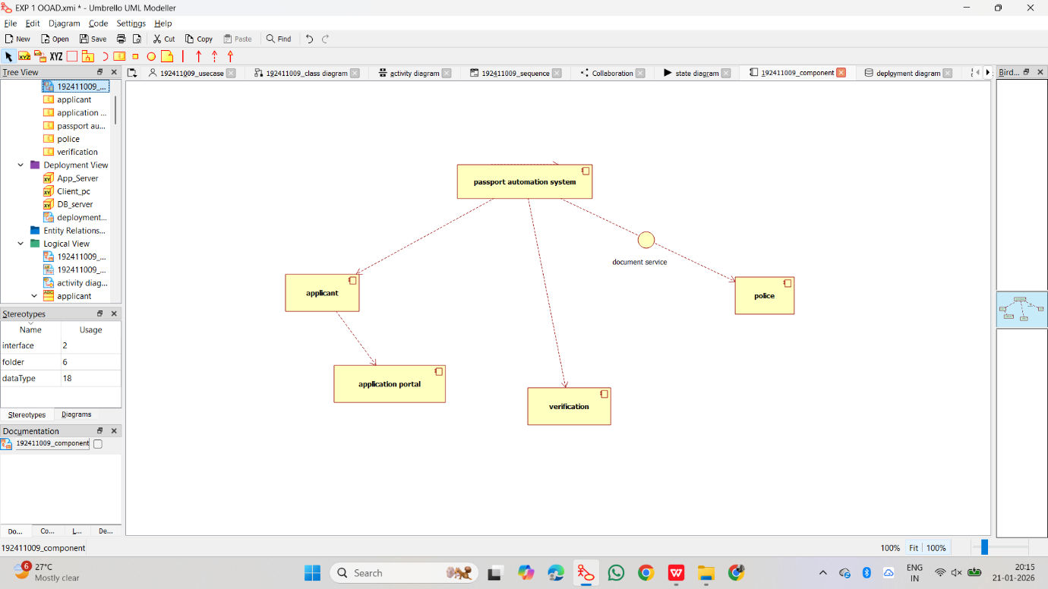
7.COMPONENT DIAGRAM:

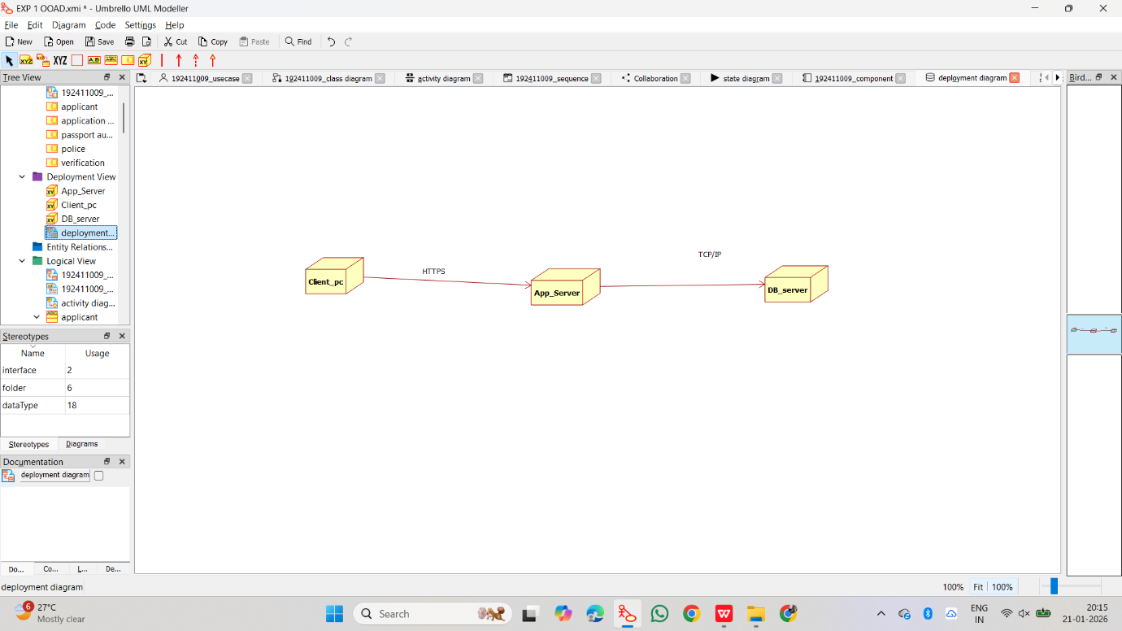
8.DEPLOYMENT DIAGRAM:

9.PACKAGE DIAGRAM:

